



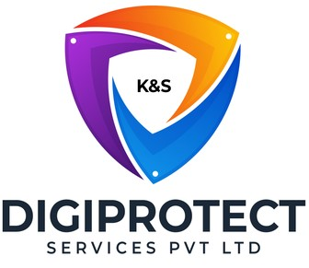

INITIAL
ASSESSMENT
REPORT

DATE: 22nd August 2024
Information Technology

VERSION: 1.2

Document History
Document version | Remarks | Submitted  By | Submission  Date | Approved BY | Approval  Date
1.0 | First Draft | k&S Digiprotect | 14th June 2024
1.1 | Second Draft | k&S Digiprotect | 6th August 2024
1.2 | Third Draft | k&S Digiprotect | 22nd August 2024

Table of Contents
Introduction 4
Objectives 4
General Information 5
SPOC Information 5
Department Hierarchy* 6
Observations 7
Data Flow Diagram (DFD) 10
Data Mapping and Inventory 11
Recommendations 13
Action Plan (ISFC to share the following) 13
Conclusion 13
Appendices 14
Appendix A 14
Appendix B – Template for Support Tickets 15

Introduction
India Shelter’s IT Department serves as a cornerstone of operational efficiency and data security within the organization, providing crucial support to the core business of India Shelter in managing critical applications and systems. As technology continues to evolve, the department's role extends beyond traditional IT functions to driving innovation, enhancing efficiency, and fostering seamless integration of cutting-edge solutions. Information security, data protection, and cybersecurity fall within the ambit of this department.
This report encapsulates critical insights for As-Is study, derived from the initial interview conducted with the Information Technology Department of India Shelter Finance Corporation Limited (ISFC) for the implementation of ISO/IEC 27001:2022 and compliance with the Digital Personal Data Protection Act (DPDPA).
The overarching objectives of this interview were dual fold: first, to gain an understanding of the departmental structure, and second, to delve into the core operational processes of the Information Technology Department. Additionally, the interview aimed to assess the existing information security practices, focusing on evaluating adherence to DPDPA requirements and the readiness for ISO/IEC 27001:2022 implementation.
By delving into the details of the department's organizational setup, operational workflows, and data handling procedures, this report aims to identify both the strengths and areas of improvement in information security management and DPDPA compliance within the department.

Objectives
- Understand the departmental hierarchy and reporting structure
- Learn the existing processes of ISFC’s Information Technology Department
- Mapping of existing processes with documented processes
- Offer recommendations to optimize the existing processes

General Information
Organization Name | India Shelter Finance Corporation Limited
Department Name | Information Technology Department
Date of the Assessment | IT - 15th March 2024  Software Development - 7th May 2024
Location | 6th Floor, India Shelter HQ, Gurugram
Meeting Duration | IT – 2 hours  Software Development – 1 hr 30 minutes
Attendees (ISFC) | Abhinav Arya, Deepak Wadhwa, Vivek Kumar Sharma, Vijay Uniyal Dheeraj Yadav, Sunil Kumar Sharma
Attendees (Digiprotect) | Lalit Mohan Joshi, Sushil Menon, Manav Mahajan, Adhita Razdan

SPOC Information
Project SPOC: Dheeraj Yadav
Contact Information:
Email ID: dheeraj.yadav@indiashelter.in

Project Coordinator: Sunil Kumar Sharma
Contact Information:
Email ID: sunil.sharma2@indiashelter.in

Department SPOC: Abhinav Arya
Contact Information:
Email ID: abhinav.arya@indiashelter.in

Department Hierarchy*

* As informed during the meeting

Observations
S. No | Key Activities | Observations and Asks | Remarks
 | IT subfunctions  - Application Development  - Application Support  - Infrastructure Support  - Cybersecurity | NA | - These contain mobile apps, and PaaS based applications.
 | Core services  - FinnOne Neo – Loan management, and accounting  - Microsoft D365 – Accounting software, standalone function  - Integration of FinnOne Neo with MS D365 is taking place.  - Salesforce – Onboarding of Customers  - Peripheral systems – Front end channels | - Super-admin role for the Treasury management system will be with the IT team. It is under evaluation process.  - For People Strong IT does not have the Super-Admin or Admin roles. They are managed separately by HR. | - Talent Acquisition system is under development by third party.
 | Applications  - iSales App – used by Loan Officers in field, and branches  - iServe App – Purely customer facing application. Servicing to existing customers. It has MFA enabled.  - iCollect App – used by Collection team on ground  - iTech App – Used by Technical verification team (in-house and partners) for property visits  - iCredit App – Used by Credit team to assess income and other aspects. The team does further assessments on loan application information.  - iTrust – New version of iSales. Currently on pilot mode.  - All applications are synced with Salesforce in real time.  - All development is done on ISFC cloud environment.  - Application development is done in-house as well as by outsourced developers through a direct contract.  - Finance & Accounts team use MS D365.  - New eKYC app development/testing in progress. | - iSales, iCollect, iCredit through one partner. Rest all are developed in-house.  - CI/CD pipeline implementation has been initiated in the iTrust App. Salesforce CI/CD pipeline is in place.  - No repository is in place for issues or bugs resolved in different apps, also known as KEDB (Known Error Database).  - Issues and defects are informed over mail, meetings, calls, etc.  - Entire key management process rights reside with CIO. No rotation process in place. | - Internal and External VAPT is conducted quarterly.  - Developers do not have access to Salesforce database.  - FinnOne database access is with MSP (Nucleus Systems).  - ISFC has a local datacentre (on-prem), managed by infra team.  - Code for Bespoke apps are stored on GitHub.
 | IT Steering Committee  - The IT Steering Committee is composed of key executives, including the Managing Director (MD), Chief Executive Officer (CEO), Chief Financial Officer (CFO), Chief Risk Officer (CRO), Chief Information Officer (CIO), and the respective business heads. | NA
 | Information Security  - All new applications developed undergo an information security check.  - The process is checklist based.  - VAPT and Information Systems Audit is outsourced | - All new developments should require an approval from the infosec team. | - Security and patch management is taken care of by the Infra and network team.
 | Change Management  - Change requests for in-house developed apps comes through support team. | NA
 | Code Repository Management  - Code Repositories are stored on GitHub.  - 5 users have access on GitHub – 4 developers and 1 DevOps.  - Limited access to upload, maker rights are restricted.  - Pull access is restricted.  - Rest of the development team has a limited access to GitHub; they are majorly in training mode. These trainees submit the code to Lead developers who then upload it onto GitHub post testing. | NA | - Outsourced developers send code to the internal development team. The code is reviewed by tech architect before it is further submitted to Business Analysts for a sanity check and UAT is performed.

Data Flow Diagram (DFD)
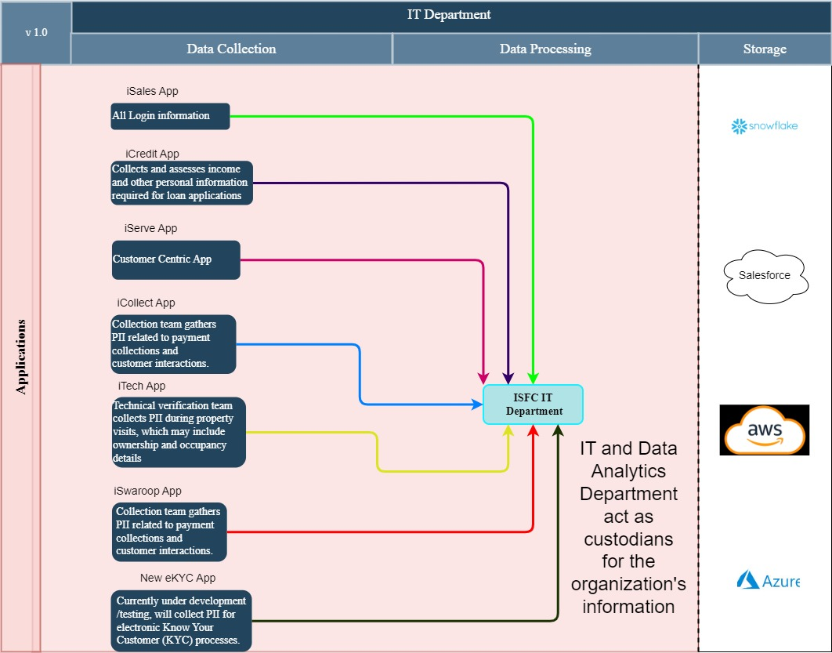

Data Mapping and Inventory
S. No | Data Category | Description | Purpose | Data Owner | Storage Location | Data Classification* | Retention Period | Legal Basis
1 | Customer Information | Personal and financial details of loan applicants and customers | Loan processing, customer onboarding, servicing loans | Sales/  Operations team/ Data Analytics | AWS, Salesforce | Confidential | As per regulatory requirements | Contractual, Legal obligation
2 | Employee Information | Personal and employment details of employees | HR management, payroll | HR Department | Local DC, AWS | Confidential | As per company policy | Contractual, Legal obligation
3 | Financial Records | Accounting details, transaction records | Financial accounting, audit | Finance Department | Local DC, MS D365 | Confidential | As per regulatory requirements | Legal obligation, Compliance
4 | Loan Details | Information related to loans including repayment schedules and defaults | Loan management, collections | Finance Department/ Data Analytics | FinnOne Neo, Snowflake Data-lake | Confidential | As per regulatory requirements | Legal obligation, Contractual
5 | Security Logs | Logs related to application access, security incidents | Security monitoring, incident response | IT Department | Local DC | Confidential | As per security policy | Legitimate interest, Compliance
6 | Application Data | Data generated by the use of iSales, iServe, iCollect, etc. | Business operations, customer service | IT Department | AWS | Confidential | As per business requirements | Contractual, Legitimate interest
7 | Integration Logs | Logs of data exchanged between FinnOne Neo and MS D365 | Integration monitoring, troubleshooting | IT Department | Local DC, AWS | Confidential | As per business requirements | Legitimate interest
8 | Development Records | Codebase, development changes, bug reports | Application development, maintenance | IT Department | GitHub, Local DC | Confidential | As per business requirements | Legitimate interest
9 | VAPT Reports | Reports from Vulnerability Assessment and Penetration Testing | Security assessments, compliance | IT Department/ Risk Department (CISO) | Local DC | Confidential | As per security policy | Compliance, Legal obligation
10 | Audit Logs | Records from information system audits | Compliance, internal audits | IT Department/ Risk Department (CISO)/ Internal Audit | Local DC | Confidential | As per audit policy | Compliance, Legal obligation
*Refer Appendix A

Recommendations
- Encrypt sensitive data both in transit and at rest to protect against unauthorized access.
- Provide regular training on data protection best practices for all employees, especially those involved in handling sensitive information.
- Implement ongoing monitoring and compliance checks to ensure adherence to data protection regulations and internal policies.
- Data Analytics team should not be the custodian of Snowflake Data-lake, ideally IT department shall be the custodian.

Action Plan (ISFC to share the following)
- NDA and Contract with outsourced company/partner
- Assessment report of risk register along with the existing risk register
- VAPT report of last quarter
- Content of training given to developers and evidence of trainings conducted in the last one year
- Checklist for third party
- Data Ledger of Personal information

Conclusion
The IT Department ensures operational efficiency and data security within the organization, particularly highlighted by its management of critical applications and systems. By fostering a culture of innovation and stringent cybersecurity practices, the IT Department continues to play a crucial role in supporting India Shelter’s goals and maintaining high standards of operational excellence and data security.

Appendices

Appendix A
Data Classification | Definition
Sensitive Data | Information that, if disclosed, altered, or destroyed without authorization, could cause significant harm to an individual, organization, or entity. This often includes financial records, medical information, and PII.
Restricted Data | Highly sensitive data tightly controlled due to legal, regulatory, or contractual requirements. Access is limited to authorized personnel, and any unauthorized disclosure may result in severe consequences.
Private Data | Information considered confidential and intended solely for specific individuals or groups within an organization. It requires protection from unauthorized access to maintain privacy and uphold confidentiality agreements.
Confidential Data | Privileged or proprietary information of an organization requiring protection from unauthorized access, disclosure, or alteration.
Public Data | Information that is freely available and accessible to the general public without restrictions or limitations. It does not contain sensitive or confidential information and can be openly accessed and used for various purposes such as research, analysis, and public interest initiatives.
PII (Personally Identifiable Information) | Data that can identify, contact, or locate an individual, either alone or in combination with other information. For example - names, addresses, official identifiers (Aadhar, Pan, DL, biometrics, etc).
Non-PII | Data that, while not personally identifiable, however may still require protection due to its sensitivity or confidentiality. This may include corporate financial information, proprietary research data, or internal communications.

Appendix B – Template for Support Tickets
(Raising and Resolution)
Excel template shared over mail along with this report.

-------------------------------End of report for IT------------------------------

